**Day11– Java Assignment**

1. **Write Xpath to find the buttons in**[**https://www.tutorialspoint.com/selenium/practice/alerts.php**](https://www.tutorialspoint.com/selenium/practice/alerts.php)

**Absolute XPath:** html/body/main/div/div/div[2]/div/button. Found “Alert” button.

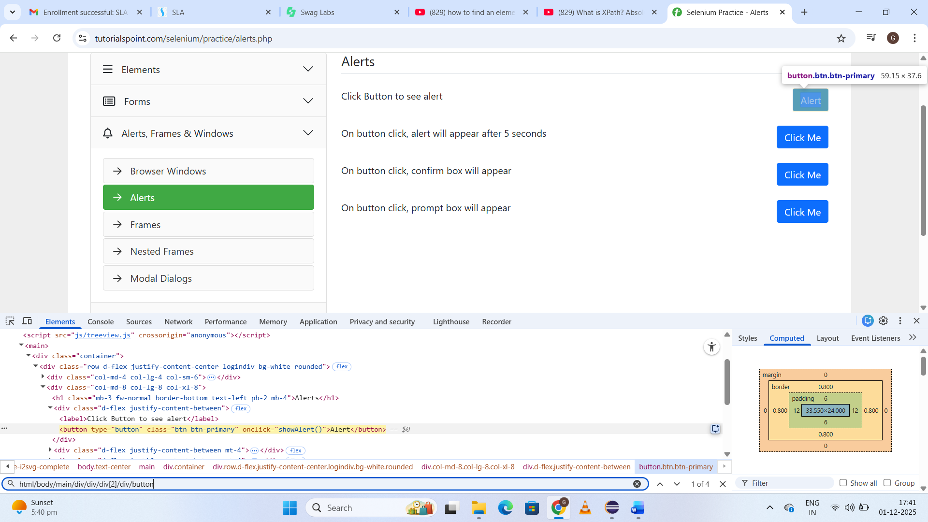

**XPath: By Tag Name and Attribute:** //button[@onclick='myMessage()'] **Click Me (1st button)**

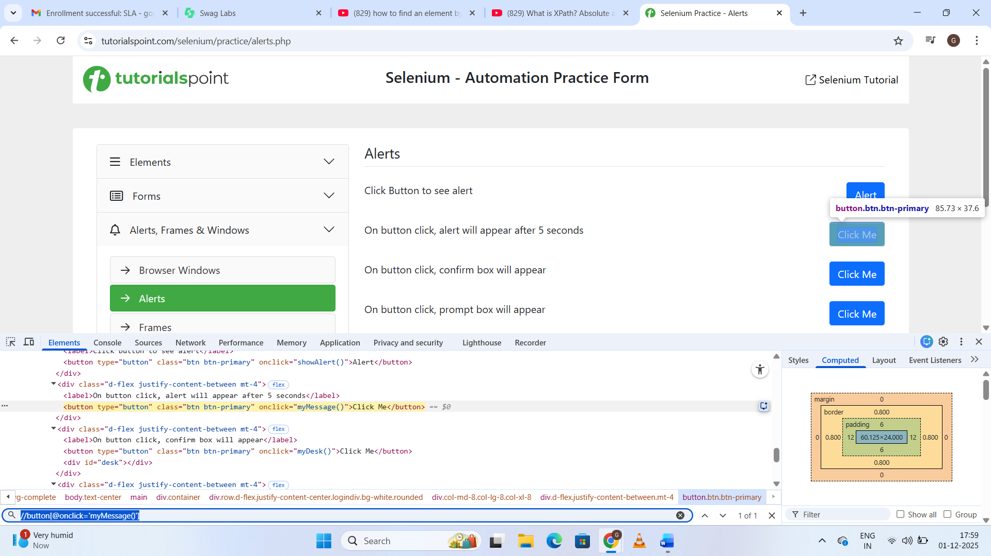

**XPath: By Text Content:** //h1[text()='Selenium - Automation Practice Form']

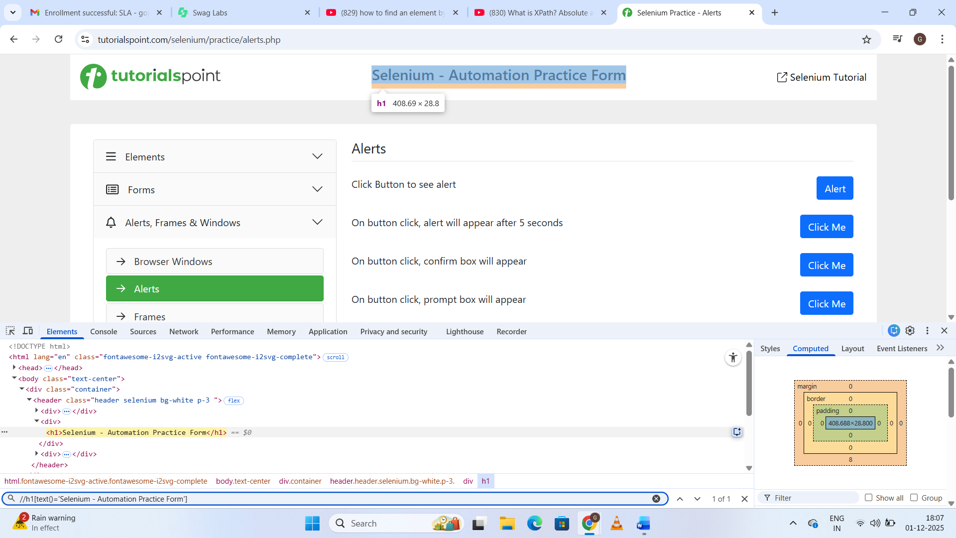

**//button[text()='Click Me'] – Found 3 elements. I selected 2nd text ‘Click Me’**

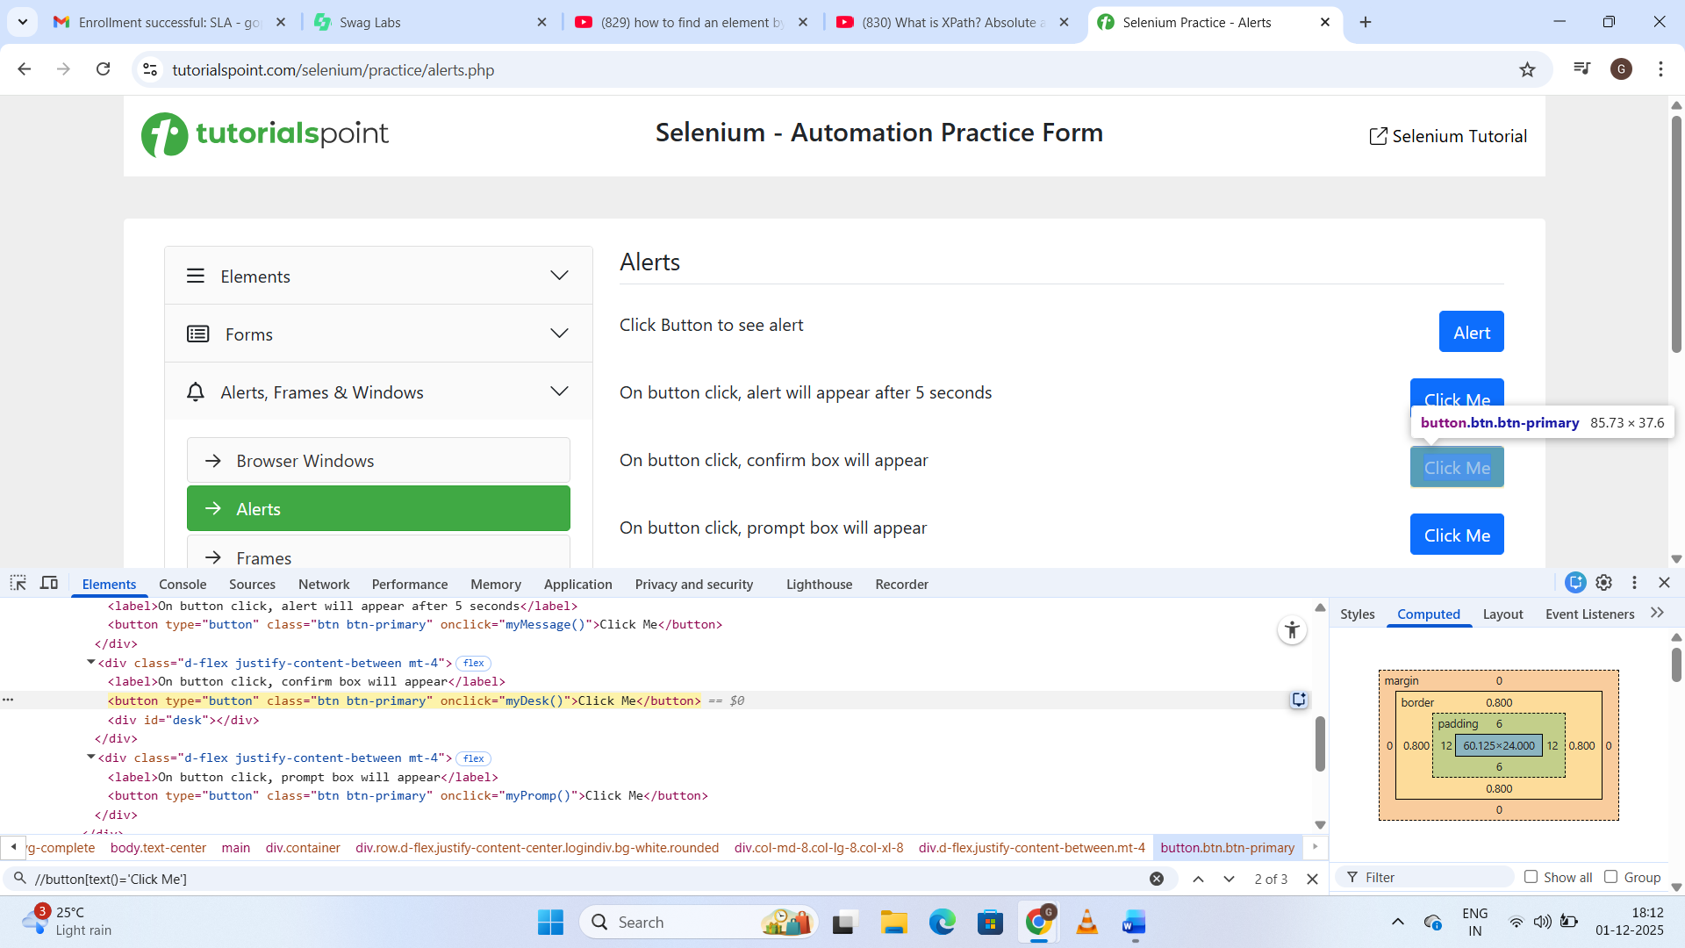

**XPath: By Using Contains() for Partial Matches -** //button[contains(@onclick, 'Promp')]

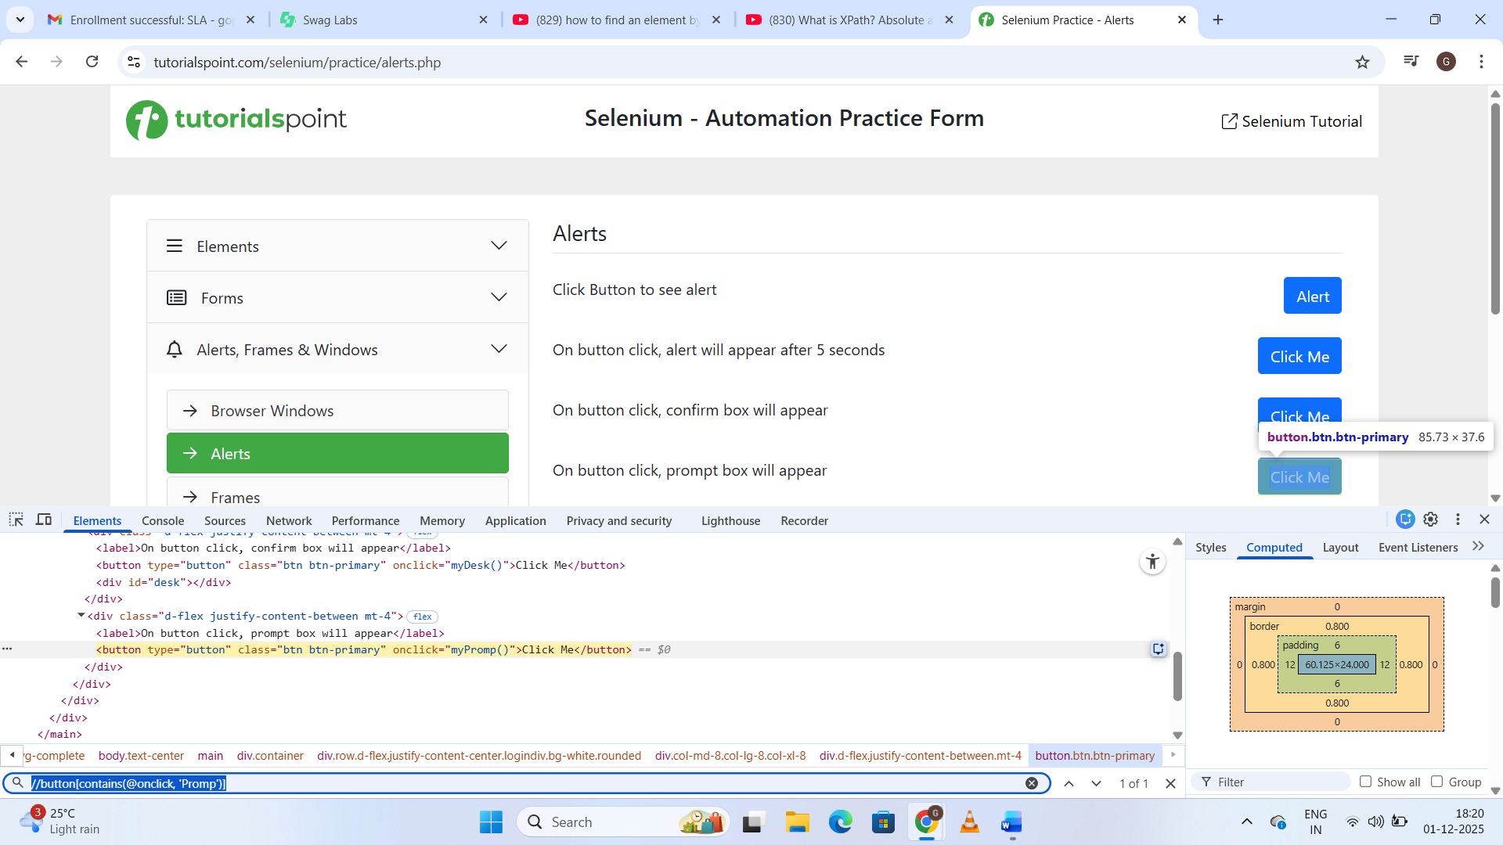

**//button[contains(text(), 'Click')] –** Found 3 elements. Selected 3rd Click Me

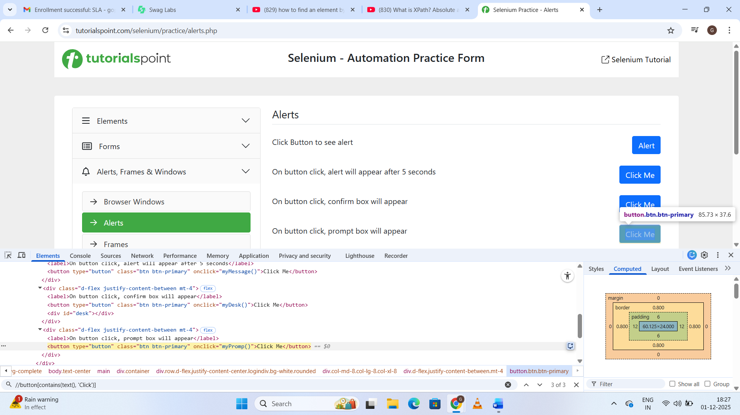

**XPath: By Using Starts-with() -** //button[starts-with(@onclick, 'myD')]

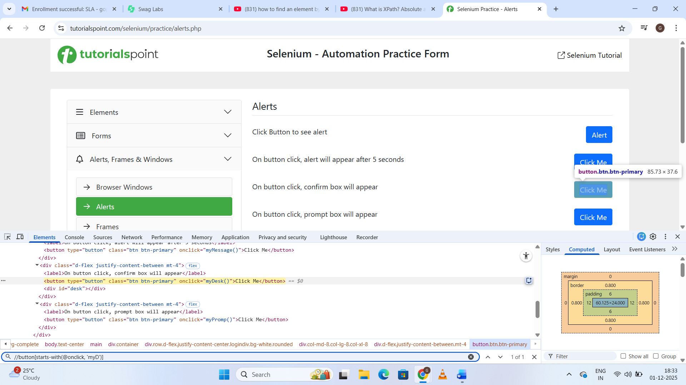

**XPath: By Using Logical Operators (AND, OR): For selecting an element using more than one attribute**

Using OR - //button[@type=button or @onclick='showAlert()']

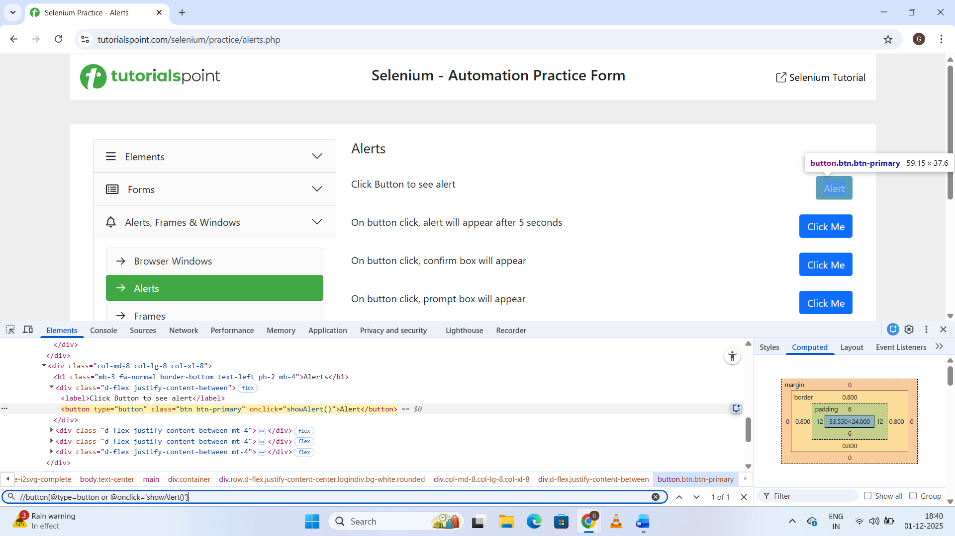

**Using AND** found 4 elements - //button[@type='button' and @class='btn btn-primary']

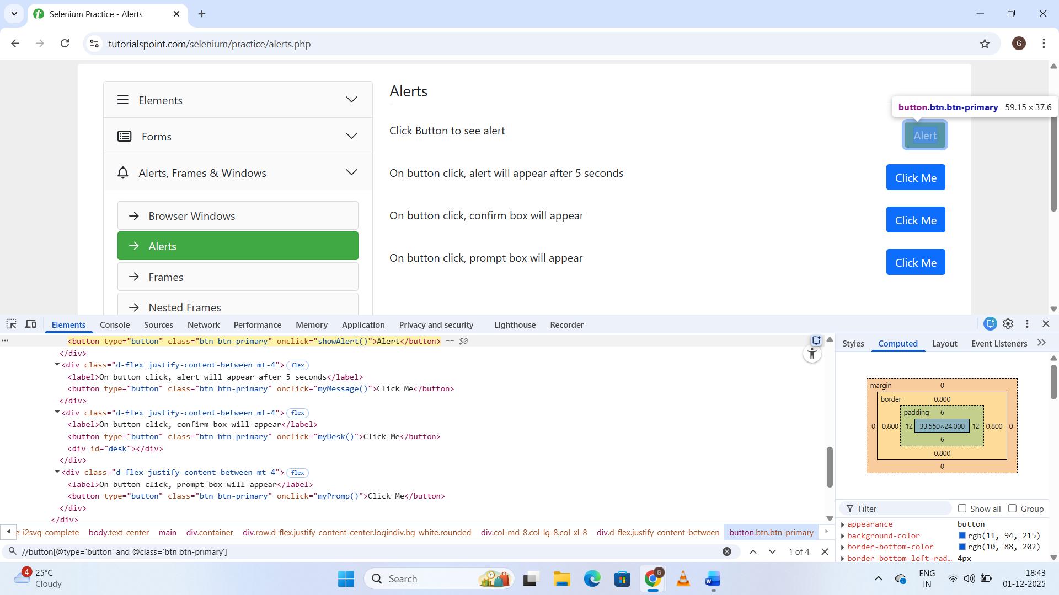

**2. Write CSS Selector for the elements in**[**https://www.tutorialspoint.com/selenium/practice/selenium_automation_practice.php**](https://www.tutorialspoint.com/selenium/practice/selenium_automation_practice.php)

**By ID:** input#name

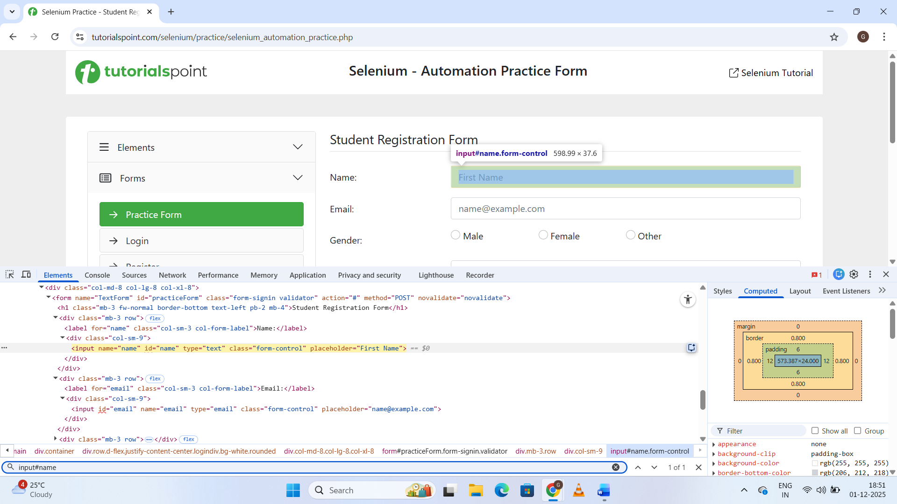

**By name: #email**

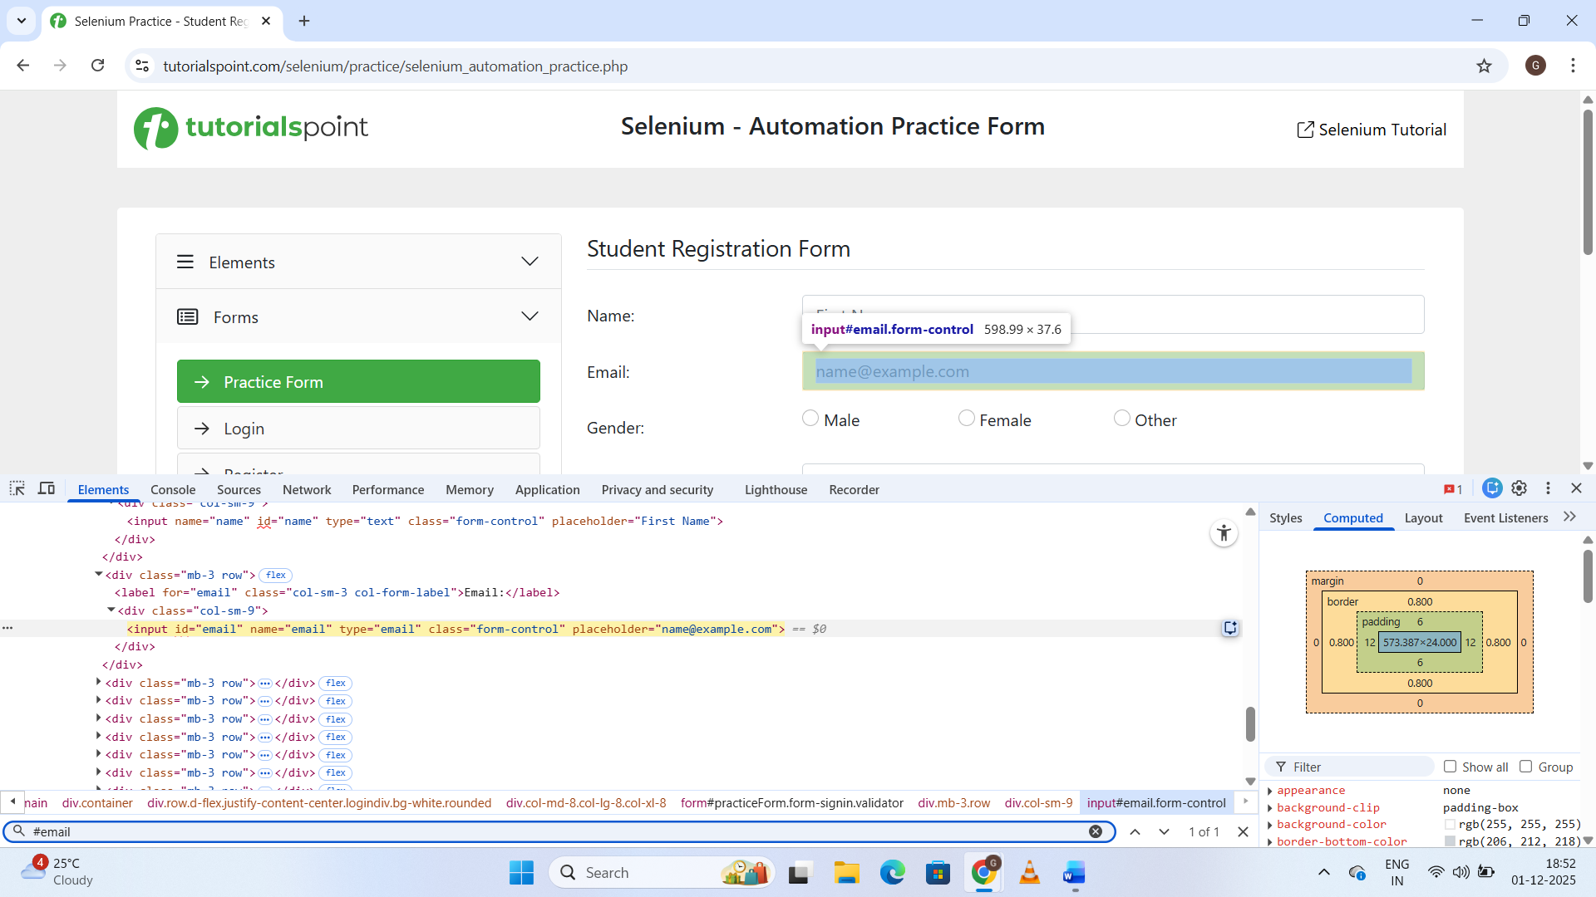

**By Class:** .file-input

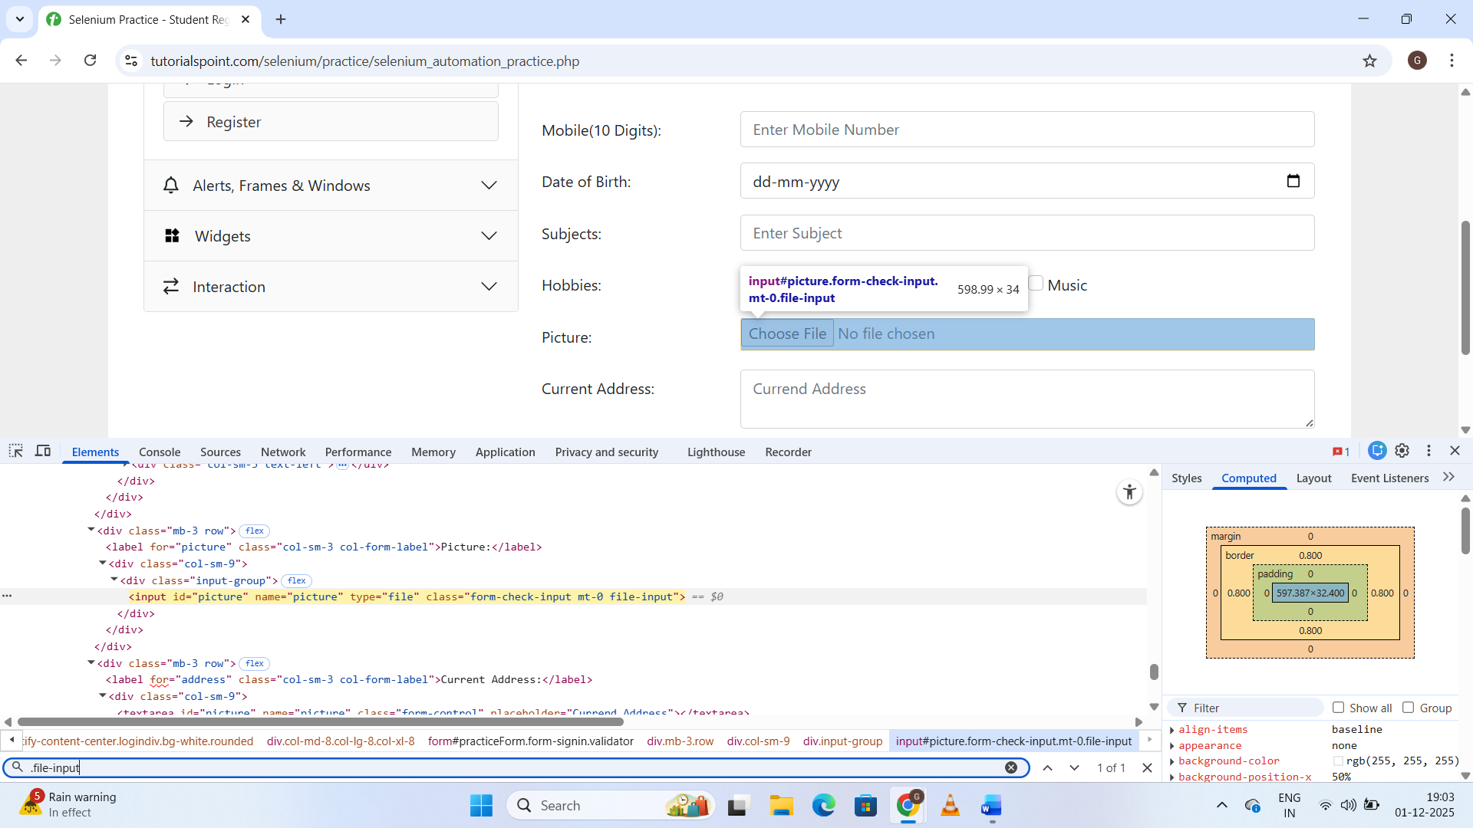

**By Class:** input.file-input

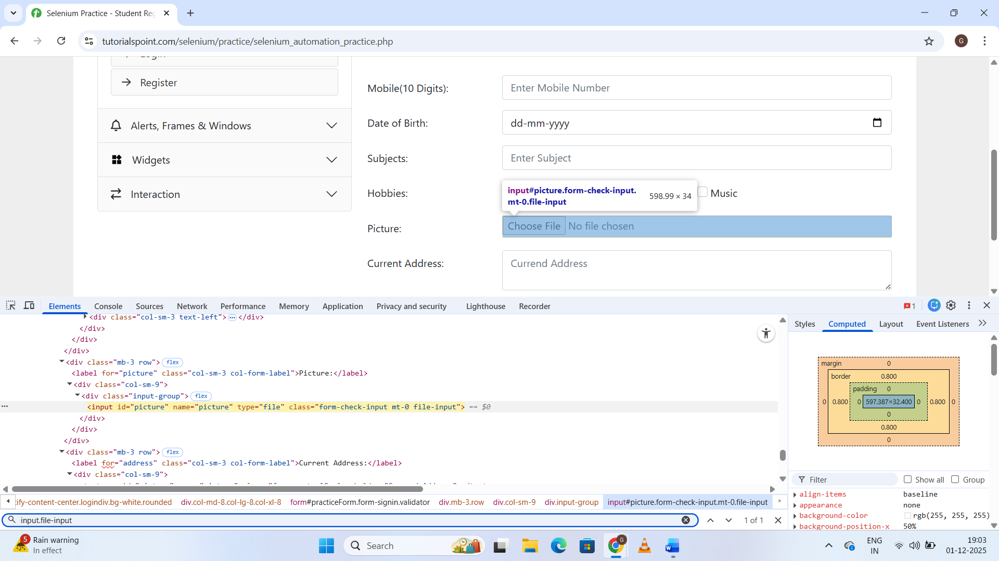

**By Attribute:** textarea[placeholder='Currend Address']

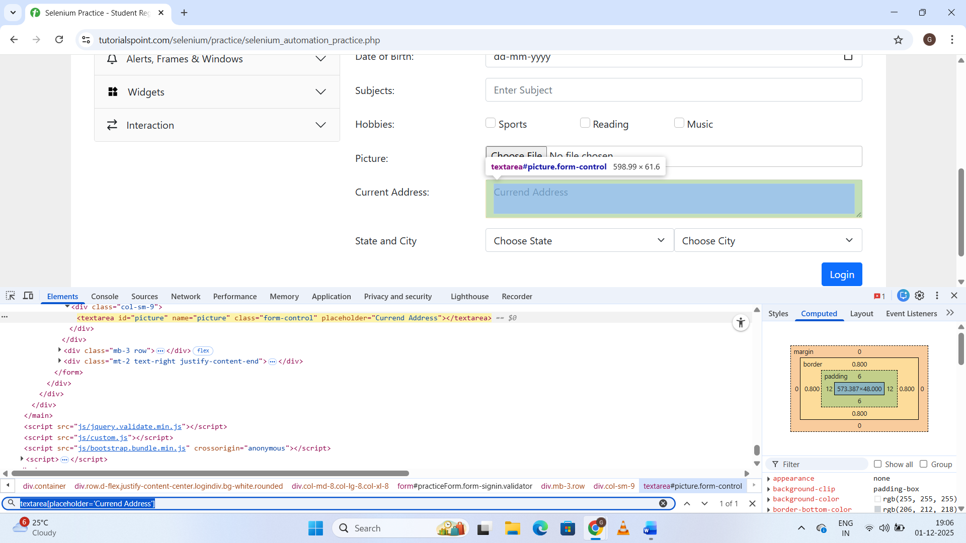

**By Descendant: div h1**

**Div – grandparent**

**H1 - grandchild**

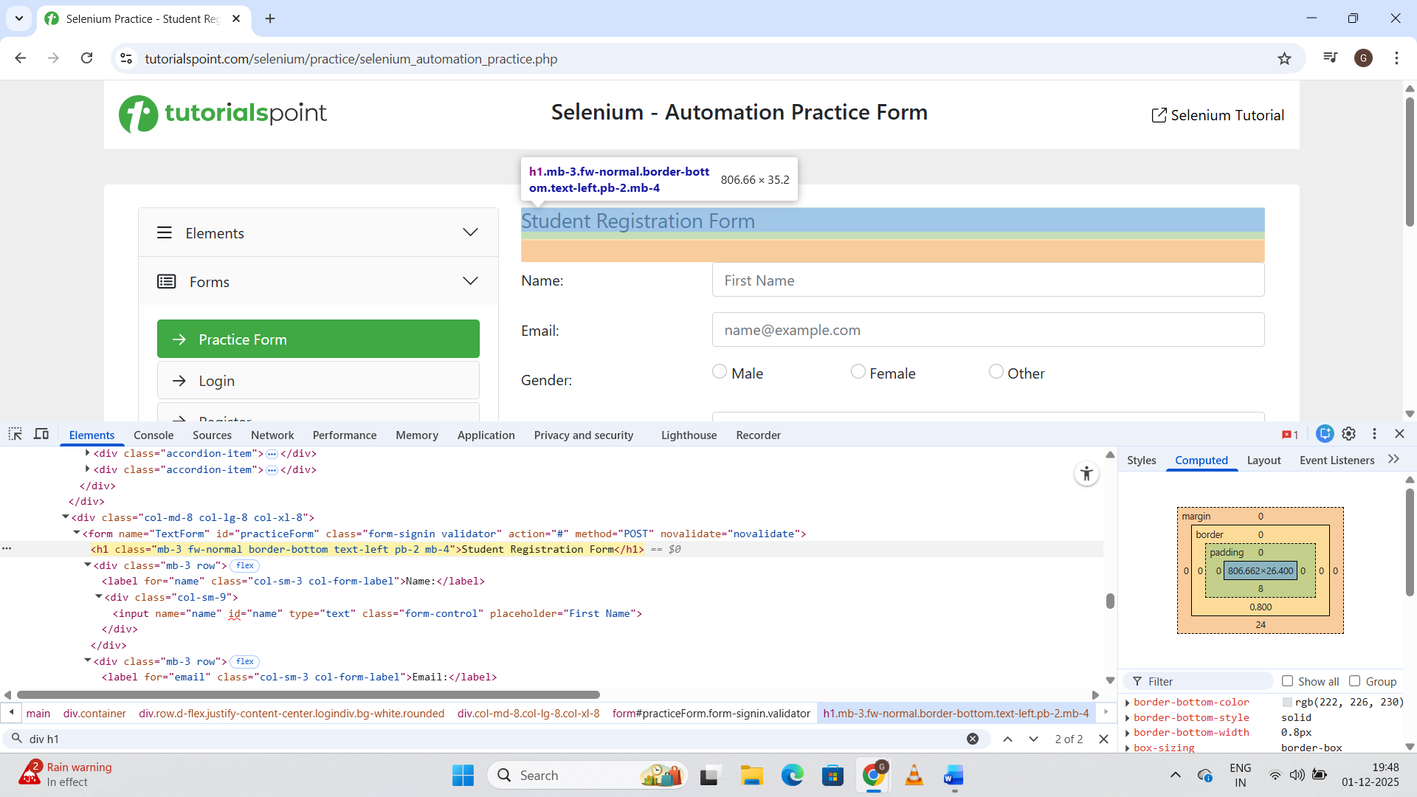

**By Direct Child – div>h1**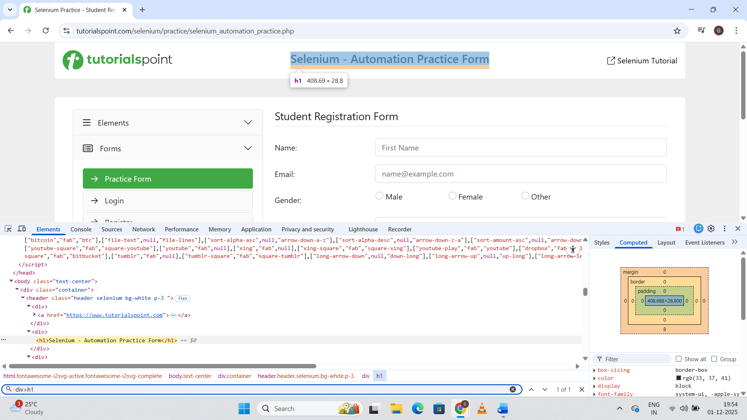

**Combining Selectors:** input.form-control[placeholder='Enter Subject']

